*Multimodality data*

Inspired by Tree-LSTM, we plan to use a clique LSTM to model multimodality time series data. In this case, each mode is a node in Tree-LSTM model, and their hidden state and memory cell state are inter-exchanged during time series sequencing. For instance, to compute the next hidden state of text data, a combination of hidden states and memory cell state of video and audio data will be the current hidden state and memory cell state of text data node. We will also have multiple forget gates for those hidden states. The mathematical formulation of computing the next hidden state and memory cell state of text data is shown below. Subscripts $t,v, a$ indicate text, visual and audio respectively.

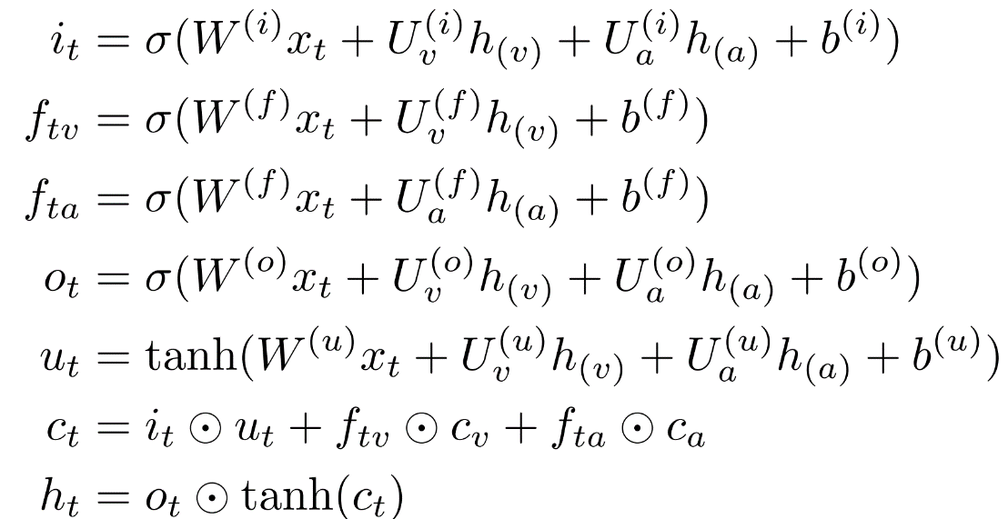

*Lesson*

After participating a series of Deep-Purple hackathon, we realize that it is not straightforward to utilize deep learning models into other academic fields like biology. We believe that the main advantage of deep learning models compared to machine learning models is their trainable feature extraction model. We have CNN for visual and word embedding for text data. These feature extraction methods are not only adaptable to a particular dataset but are also transferrable to other datasets in the same field. In biology, we usually have less amount of data and the feature extraction model for biological data remain unclear. It would be better to start from a large biological dataset first and then explore proper feature extraction methods which can be transferred to other biological datasets.

We also have some difficulties with the computation platform Xsede. Despite of the fact that we are issued GPU service units, the platform does not allow the users to install packages. For example, our lab uses Pytorch as our deep learning frameworks, but only Bridges support a very old version of it. We have to submit tickets to ask for them to install it. It would be better that the users can have their own Virtual Machine Image or at least grant some freedom on software installation.